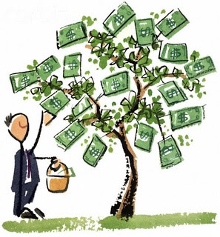

[This Photo](http://www.duperrin.com/english/2013/10/17/digital-economy-digital-assets/) by Unknown Author is licensed under [CC BY-SA-NC](https://creativecommons.org/licenses/by-nc-sa/3.0/)